Instructions for preparation of abstracts for FNTG49
second line of title if needed

○Taro Kyudai¹, Hanako Kitakyu², Ken Fukuoka¹

¹ Department of Applied Chemistry, Kyushu University, Fukuoka 819-0395, Japan
² Department of Engineering, Kyushu University, Fukuoka 819-0395, Japan

This is a sample abstract for FNTG49. Please follow the instruction below for preparing manuscripts.
1. Its overall layout is similar to that used for the previous FNT meetings. Abstracts should be written in English. The abstract should fit on one A4 page without the page number, within top and bottom margins of 30 mm and side margins of 25 mm. The abstract should be submitted in PDF format with the file size less than 5 MB.
2. Use Roman font or a similar font such as Times New Roman throughout the abstract. The recommended font sizes, as used in the Word template, are listed in Table 1.
Table 1. Font sizes to be used in the abstract.
 | Title | Body | Captions | Refs.
Size | 14 pt | 12 pt | 10 pt | 10 pt

3. The title should be typed in 14 pt boldface font and centered. Leave 12 pt before the names of the authors (12 pt) and again before the single-spaced affiliations and addresses (12 pt, Italic). After 12 pt vertical spacing the body text is typed
4. Figures will be shown in black and white. Give each figure a separate caption (10 pt). It is your responsibility to ensure that the figures are easy to read and understand even in grayscale mode. Pay close attention to the file sizes to avoid producing an oversized final PDF abstract file.
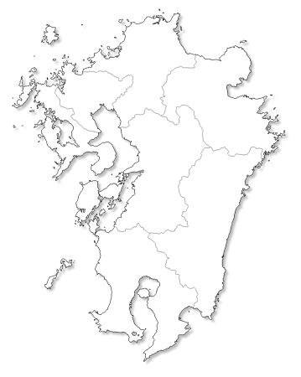
Fig.1: Schematic map of Kyushu island.
5. References in the text should be given by numbers in square brackets [..]. The list of references in 10 pt font follows the last line of the text with one extra line inserted. A long list of authors can be replaced by “et al”.

[1] K. Fukuoka et al. Carbon & Sci. Rep. 123, 456 (2015).
[2] ….
[3] ….
Corresponding Author: K. Fukuoka
Tel: +81-92-123-45#7, Fax: +81-92-123-45#7,
E-mail: author@domain.jp

